Analysis - Mare Of Easttown

Mare Of Easttown was a show I randomly stumbled across while pondering what to watch on a particular night. I remember being upset that it had only one episode uploaded, while I was in the mood for a marathon. I finished the episode and shut it out of my memory for a few weeks.

Recently, I stumbled upon it, while pondering what to watch, as I walked on my new foldable treadmill. Seeing it had three episodes uploaded, I decided to give it a shot and I ended up being hooked.

Now, with the completed series under my belt, I figured it’s time to give an analysis of the show.

Disclaimer - This is based on personal opinion and is bound to have inevitable spoilers.

Mare Of Easttown is a special case of jam-packed individuals with so much personal baggage, that they all find a way to run from their problems. They do this by occupying themselves with new or old routines and turning a semi-blind eye to every mounting event. It is an incredibly traditional town, in the sense of ignoring to forget and transferring aggression to feel better.

The town needs a scapegoat for their transferred aggression, one who is ready to take the fall for anything and everything, regardless of the individual’s opinion or right. The town needs a mother to lead the way. No matter how hard they all try to function, they really can’t without their mother. The mother needs to lead, the mother needs to solve their problems, the mother needs to accept the transferred aggression, the mother is Mare. We will get to Mare in a little bit.

Basically, in this dark town filled with lies, murder, kidnapping, incestuous behavior, and many more, the adults continue to pass down their infectious darkness to the younger generation, the circle continues. Even in the midst of young and old, the same pattern rears its ugly head.

The town is angry, the town is filthy, and the town won’t hesitate to take it out on Mare. With the police department, notice how no one throws tantrums with anyone else in there? Not even with the chief of police? Yes! Mare, believe it or not, has a position that is offensive to most in the town. Remember, this is a very traditional town and Mare doesn’t have a traditional position. She is the detective of the town.

The chief of police is like a father to Mare. He gets it, he should. He is a person of color and based on his age, it must have been a difficult journey to the position of chief in Easttown. He knows what it’s like to be different, to not be liked, and to face challenges that you may or may not have signed up for. He sees the fire in Mare, he knows underneath it all, there is a good heart constantly fighting for the good of the people. Someone who truly loves her children (the town) and will do anything and take all crap needed to provide and protect. Just like a mother would.

In this world, mothers, sadly, are always at fault. They are also the most loved. It’s a harsh reality.

Let’s use Mare’s household as an example. Mare’s mom (Jean Smart) never fully grieved the death of her husband. Instead, she turned towards whatever got her through the day like having an affair with a married man, drinking, or having a pint of ice cream in a cereal box and staying oblivious to the obvious. Mare, on the other hand, became a full-blown, stone-faced adult overnight, never fully grieving as well, and turned to the next thing to distract her; following her dad’s footsteps to save the town. When her son committed suicide, the family fell apart with Mare not being able to grieve, the husband moving on to the next distraction which became the newfound love that almost fell apart, and the daughter finding her distraction in the semi-bad company, alcohol, and drugs, which eventually fell apart. Luckily, with Mare’s family, the distractions falling apart was the stepping stone to mending the crack between them and healing slowly. Although I am not a fan of the rushed forgive and heal ending within the family, I am happy that they were able to meet halfway. It was nice to see the positive progression towards the end of the series.

The women and the young are suffering deeply in this town, the men as well. However, majority of the men do whatever they want with no consequences, this can’t be said for the women. Everyone is just trying to survive the best way possible, make enough money to get out of town, and trying to find their little sense of belonging. Unfortunately, this makes most of the women easy targets in Easttown. So many families were torn apart, it was incredibly heartbreaking to watch. A town so troubled, that so many lines and grey areas were crossed due to extreme toxicity, negligence, ignorance, laziness, and being stuck in their comfort bubble. The more Mare tried to fix the town, the more uncomfortable things became for everyone within, which is great because whoever said breaking the comfort circle was easy? Besides, that whole town truly needed an exorcism.

Now, let’s focus on the center point of the show, Mare.

Mare (Kate Winslet) unintentionally took on the massive responsibility of being the mother of Easttown. Whether she truly knew what she was stepping up for we will never know, but signing up to join the force and becoming a detective was signing up to become the town’s mother. As an individual, she’s broken both internally and externally. Every minute is a ticking timebomb. She just doesn’t have enough time to do anything self-help-related. She hasn’t grieved since the death of her father, add her son’s death to that equation, then the fallout of her marriage, the fallout with her daughter, the love-hate relationship with the town, the constant disagreement with her mom, the mother of her grandson claiming custody, and throwing friendly reminders of how her son hated her, the guilt of her not being good enough, now the new murder mystery case, Christ! It’s too much, no wonder she’s numb. How does anyone expect such a human to be flexible enough for a smile?

Mare may come across to some as a very unlikable character, but pay further attention and you start to realize that she’s the most lovable and trustworthy fella you will ever come across in Easttown. Despite that, Mare was also one of the most misunderstood characters, who was stuck in limbo and just going through the motions…until Richard (Guy Pearce) and Colin Zabel (Evan Peters) came along. Hi, Zabel! 👩🏾‍🦱

Glancing through several comments on the web, I came across some interesting ones with people expressing their thoughts on not liking the romance between Colin and Mare and preferring Richard. It’s easy on the surface to see why Richard will be the ideal match of preference. He is age-appropriate, has the most stable career field as a writer and lecturer, has been able to piece his life together, and most of all, he has balance. Of course, he is the perfect specimen to fit in society’s expectations. Did I mention how incredibly charming and good-looking he is?! How he knows all the right things to say, the flowers, yeah, perfect specimen.
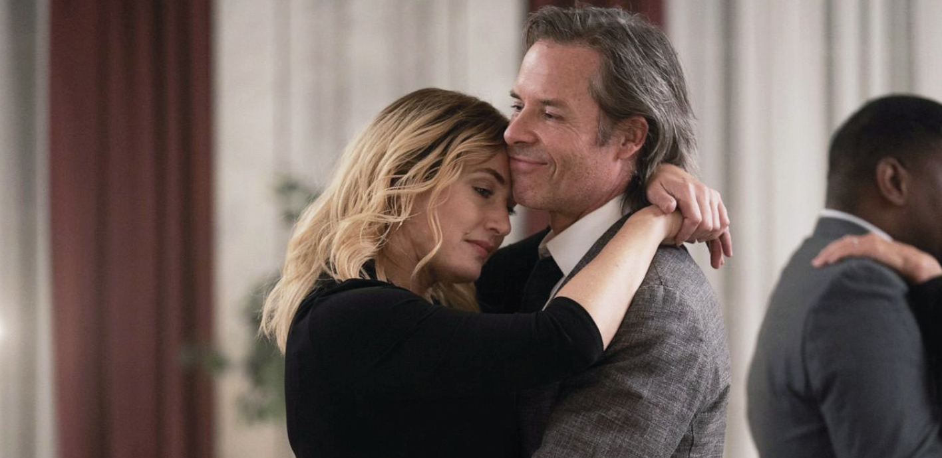
But, that’s the problem. He has his life together, he has gone through his darkness and has found his light. He is way ahead of Mare. Mare does not fit into this bubble and she is not one to compromise. Mare has too many responsibilities on her hand, she needs someone that sees her and instinctively gets it. She pushes people away, it’s nothing personal. You can be stubborn and meet her halfway or you can be gentle and ask her to reach out when she’s ready. Spoiler alert, she won’t. Mare does not have time for romantic rendezvous.
Enter Colin Zabel. Colin is naturally charming, goofy, and weird. The thing about Colin is that he has personal baggage, guilt, insecurity issues, he is stuck in a limbo of false personnel to fit the masses. He lives with his mom who sometimes oversteps, and Colin on the other hand tries to please her but also knows when to remind her to get back in her lane. In reality, he needs to break free but he also needs a natural easing process. Sometimes, the best things in life come naturally. Sometimes, an interesting challenge is all we need to break free and find our identity. It becomes the missing piece, the strange fresh air we never knew we needed.

That’s what Mare did to Colin, That’s what Colin did to Mare.

Colin was initially taken aback by the reaction from Mare during their first encounter. Despite all the warning signs to stay away, it excited him more to reach out. You don’t want to say hello? Bet you’d like coffee. You don’t want to talk to me? I guess we are riding in awkward silence. You are not hungry? How about beer then? All of which was annoying and appreciated at the same time by Mare. No explanation needed.

While he may be the fresh air the town thought they needed, and the hotshot they worshipped, he understood his place, admired Mare’s strength, and understood the unspoken body language. They didn’t need an entire series to make that connection, no, that connection was instant. That fresh air was what Mare needed to start the wake-up call to facing her demons. That connection was what Colin needed to face his dilemma of acknowledging his flaws, owning up to his mistakes, and being free to be who he truly wanted to be. He needed someone that saw him for who he was, without the need or unnecessary effort to prove to be someone else or explaining who he is. Mare saw him, Mare sees everyone. That’s also another reason why the town loves and hates Mare at the same time.
The death of Colin was remarkable in a messed-up way. Did you notice that he went out in style? His first victory was more of a stolen victory. He harbored that guilt for so long and finally came clean on the day of his death. However, he fulfilled his wish to do something big and great by solving the case of the missing girls with Mare. It was redemption. Colin did his homework AND he didn’t make a mistake this time by missing anything. He took his time to learn through Mare and with her, he grew in his career and as an individual within the short time spent together on the case. They found the right guy, and while they should have pulled back and insisted on calling for backup, He protected her in his dying moment, by taking charge while she was helpless (no gun), and pulling his gun, which gave her split seconds for hiding. He died on his first big case that wasn’t stolen but solved the right way, with no guilt attached. He died a free man who not only confessed his wrongdoings, he also freely expressed himself, acknowledged his feelings for the woman in front of him, and had the opportunity to kiss her. For once in his life, he encountered someone who truly saw him and knew what he wanted.
Remember that huge, adorable smile on his face when he said “How do you know what I want?!” right after kissing her? Yes, he died a happy man, despite it being an incredibly sad and messed up situation. I truly wish they had the time to explore and grow together as individuals, friends, and hopefully, lovers.
Speaking of the kiss of death. When Colin kissed Mare, I felt that. See, some online comments noted zero chemistry on the kiss, but I beg to differ. The kiss wasn’t necessarily about chemistry, it was that inexplicable feeling of relief, joy, love, uncontrollable happiness felt when you find that friend or someone who just gets it. They know what you are thinking and they are ready to get it done with you. No explanation needed, no excuse, they are ready, let’s go! If you have never encountered that moment, it’s magical and if you have, then you remember the first time and how it truly felt. To have that moment come from someone you like or are romantically attracted to, it’s beautiful, and it sometimes leads to a full-on, pressurized kiss, of thanks and passion.

The close-up in the death scene was very important for a lot of reasons. Remember, when Mare and Colin hit the reset button, Colin reassured Mare that this will always be her case, he was just there to help solve the mystery. They worked and learned together, this is Mare’s case. When Colin noticed the obvious giveaway of the cigarette, he turned to Mare and called out her name quietly. That’s him waiting on the signal from the case owner. Mare instinctively relies on her partner and passes the decision to him by showing him the obvious, she had no gun.
It was now up to Colin to make the call and protect the town. Colin made the decision there and then to be the guardian of the town, the guardian of the girls, and the guardian of Mare. He stood up to the challenge, knowingly placing his life on the line for the safety of everyone. This is why the unspoken language between him and Mare is incredibly powerful in this show, and why the closeup of all the body language was incredibly important in this scene. Just like Mare, Colin, at that moment was the Mare of the situation. That’s another reason why I believe his death was a courageous, victorious bow of respect.

His death to me was Mare’s breaking point. That was the break she needed to crack in therapy and slowly start to heal. It worked. With her eyes slowly opening to her surroundings, she did one of the healthiest things she had ever done in the whole show, confessing to Richard and ending things. That was such a relieving moment. Richard was under the impression that things will be alright and will slowly fix themselves but Mare doesn’t need to be fixed, Mare needs to be understood. While he may not have intentionally gone that route or voiced it, placing Mare in a world she doesn’t belong and not making the necessary adjustments to blend both worlds just won’t work. It had always been a relationship of convenience, things seemed a bit too forced from the beginning, that gets exhausting very fast. Add that to the stress of being the mother of the town, the mother of the house, and a mother to yourself, and it’s bound to be a complete disaster of a relationship. Although the show tried to create a false rekindle narrative towards the end, I am glad it ended as goodbyes.

One last thing to add to the love that never developed between Mare and Zabel, notice how Mare never truly smiled all through the show and always had her vape to calm her nerves? Pay close attention and you will notice that the only times Mare truly smiled, felt amused, nervous, and happy was with Colin Zabel. The reset scene, the kissing scene, and changing multiple times for dinner...
Mare may not be great at conversing or taking the hint when on a date per se, but Mare, underneath that stone-cold look, had little butterflies for Colin Zabel and together, they were the cutest thing on the show.

The final episode showed once again how the toxic behavior of the adults affects the young. How people are so quick to shift blame and put their burden on others, a lot end up running away from their responsibilities and having no self-awareness of the damage done. It showed the pain and sacrifice the women of the town have to go through to protect the ones they care about and love, and finally, it showed that in the end, it is possible to heal and forgive. Like I stated earlier, I am not a big fan of how quickly and unrealistic the healing process was, especially with Mare’s family, but I do appreciate the healing and forgiving process between Mare and her best friend, Lori.

Overall, It was a beautiful show with an incredibly talented cast. From cinematography to acting, I thoroughly enjoyed the show and look forward to something just as refreshing and possibly better.

